BigData Project 3: Sentiment Analysis for tweets.

Alumno: LEO RAMIRO SOLORZANO

PANTALLAS DE REPORTES

1) Sentiment MAGA.

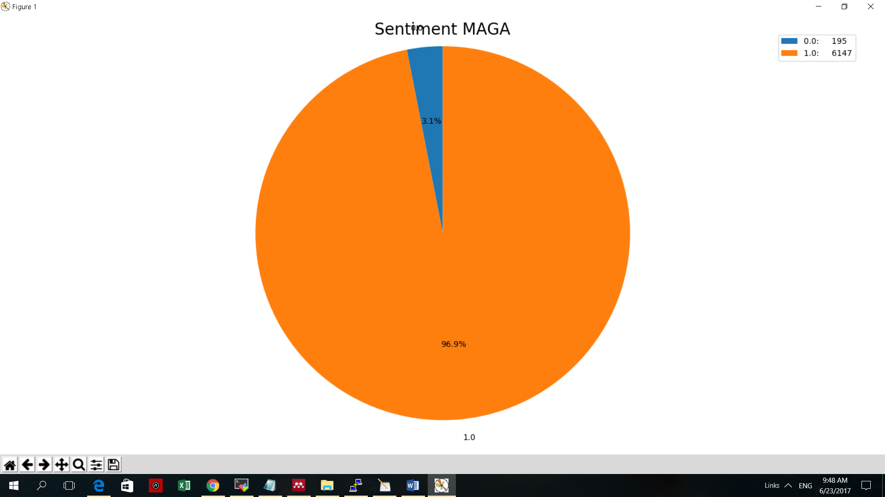

2) Sentiment COMEY.

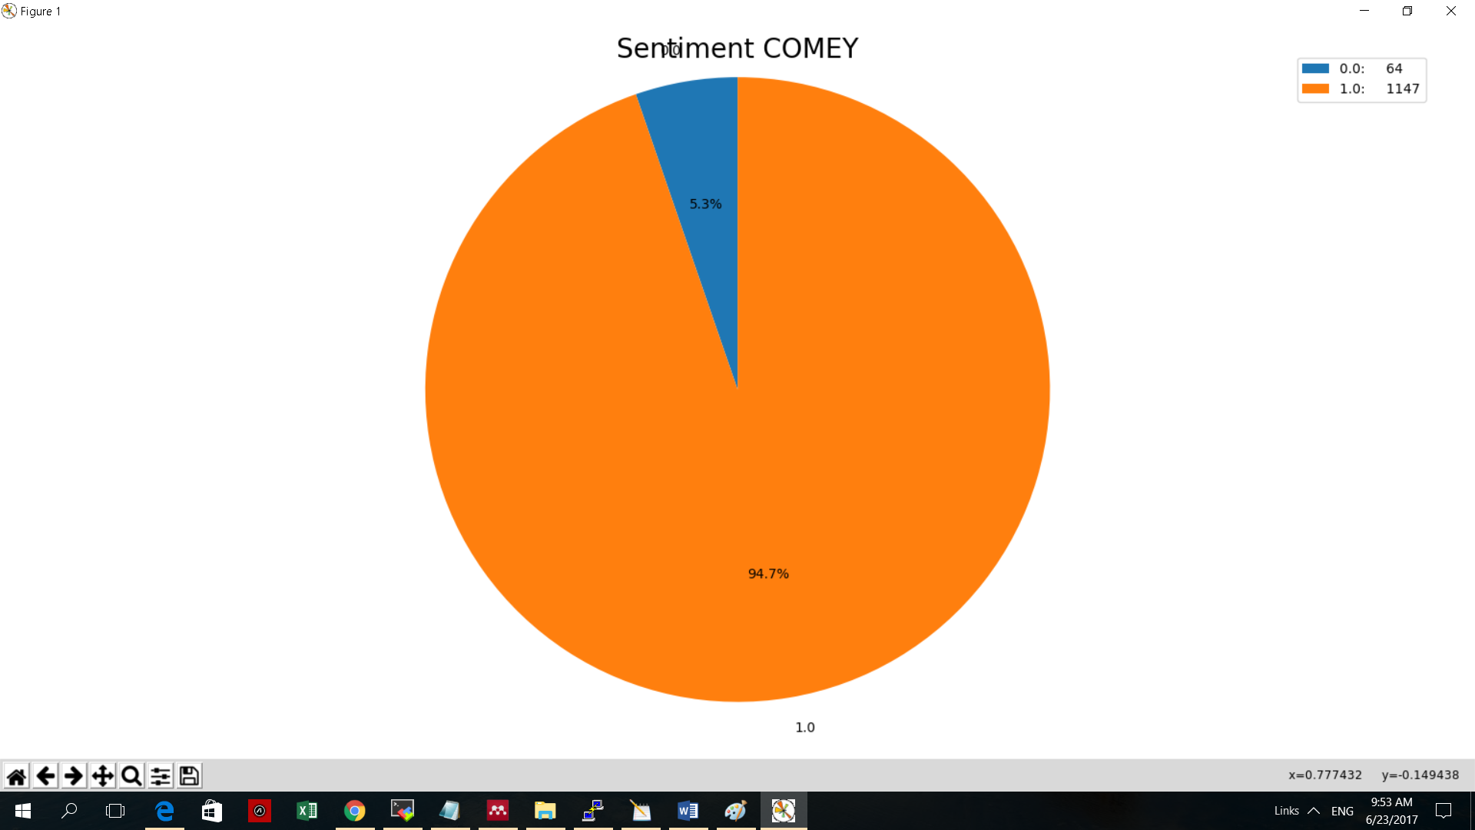

3) Sentiment DICTATOR.

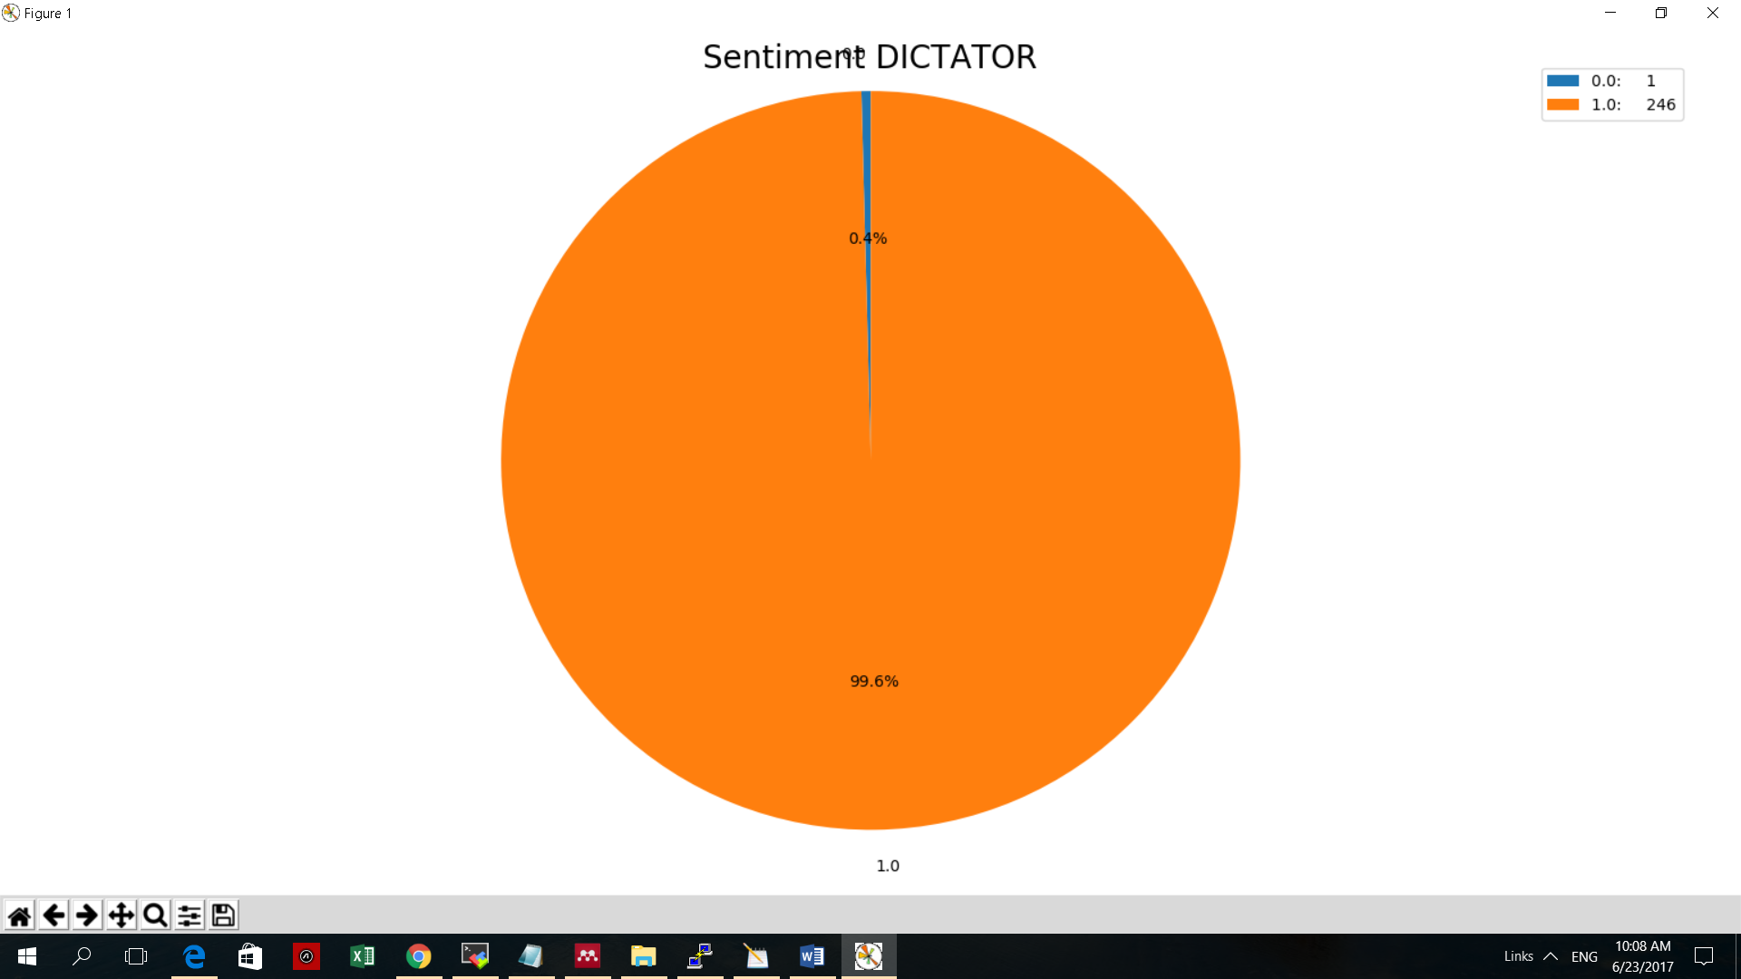

4) Sentiment DRAIN.

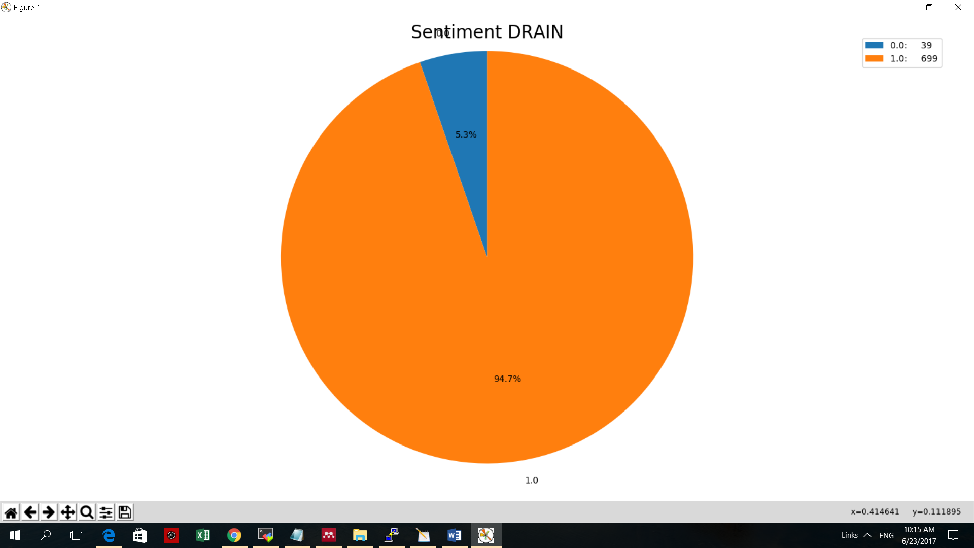

5) Sentiment IMPEACH.

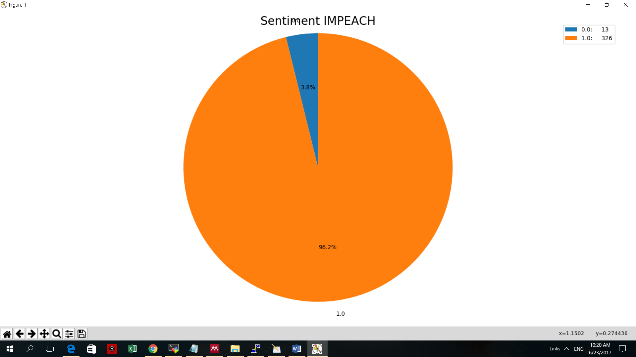

6) Sentiment SWAMP.

